COUNCIL ASSESSMENT REPORT
HUNTER AND CENTRAL COAST REGIONAL PLANNING PANEL

PANEL REFERENCE & DA NUMBER | PPSHCC-187 – DA/678/2023
PROPOSAL | Alterations and additions to the existing educational establishment, St Cecilia’s Catholic Primary School
ADDRESS | 7-15 Panonia Road, Wyong [Lot 22 in DP 569261 and Lots 4-8 in DP 4361
APPLICANT | Caladines Town Planning Pty Ltd
OWNER | The Trustees of the Roman Catholic Church for the Diocese of Broken Bay
DA LODGEMENT DATE | 31 March 2023
APPLICATION TYPE | DA Integrated - NSW Rural Fire Service
REGIONALLY SIGNIFICANT CRITERIA | Clause 5 Schedule 6 of State Environmental Planning Policy (Planning Systems) 2021 as it comprises private infrastructure and community facilities over $5 million.
CIV | $ 6,435,240 (excluding GST)
CLAUSE 4.6 REQUESTS | N/A
KEY SEPP/LEP | SEPP (Planning Systems) 2021  SEPP (Resilience and Hazards) 2021  SEPP (Biodiversity and Conservation) 2021  SEPP (Transport and Infrastructure) 2021  Central Coast Local Environmental Plan 2022
TOTAL & UNIQUE SUBMISSIONS KEY ISSUES IN SUBMISSIONS | No submissions
DOCUMENTS SUBMITTED FOR CONSIDERATION | - Accessibility and DDA Assessment Report, prepared by MBC Group and dated 24 March 2023  - Arboricultural Impact Statement Report, prepared by Mark Bury Consulting and dated 3 February 2022  - Architectural Plans, prepared by Gardner Wetherill Associates and dated 27 March 2023  - BCA Capability Statement, prepared by MBC Group and dated 30 March 2023  - Bushfire Assessment Report, prepared by Building Code and Bushfire Hazard Solutions Pty Limited and dated 9 December 2022  - Flood Assessment, prepared by Molino Stewart and dated 18 April 2023  - Landscape Plans, prepared by Umbaco Landscape Architects and dated March 2022  - Noise Impact Assessment Report, prepared by Hadie Artiel and dated 30 March 2023  - Preliminary Cost Plan, prepared by Altus Group and dated 15 November 2022  - Statement of Environmental Effects, prepared by Allan Caladine and dated March 2023  - SEPP (Transport and Infrastructure) 2021 – Chapter 3, Schedule 8 Design Quality Principles in Schools, prepared by Allan Caladine and dated June 2023  - Stormwater and Water Cycle Management Plan, prepared by Bligh Tanner and dated 23 March 2023  - Survey Plan, prepared by Mepstead and Associates and dated 27 July 2022  - Waste Management Plan
SPECIAL INFRASTRUCTURE CONTRIBUTIONS (S7.24) | None
RECOMMENDATION | Approval
DRAFT CONDITIONS TO APPLICANT | Yes
SCHEDULED MEETING DATE | 9 August 2023
PLAN VERSION | C
PREPARED BY | Alexandra Hafner
DATE OF REPORT | 23 June 2023

EXECUTIVE SUMMARY

The subject development application, DA/678/2023, seeks consent for the alterations and additions to St Cecilia’s Primary School at No. 7-15 Panonia Road, Wyong. Specifically, the proposed development includes the following:

- On-site preparation works, including the demolition of four existing classroom buildings, each shown on the accompanying architectural plans as Buildings, A, C, G (demountable) & I

- Demolition of ancillary structures, including access stairs and ramps

- Minor excavation works including the removal of existing astro-turf

- Removal of four trees

- Construction of a new two storey building facing Panonia Road with interactive outdoor learning areas, stairs, lift and amenities at ground level

- Provision of six attached Level 1 classrooms with outdoor learning areas and amenities over the ground floor interactive outdoor learning areas (undercroft area)

- Outdoor amenities

- New landscaping; and

- New seating, stairs, and access ramps.

The subject site is known as No. 7-15 Panonia Road, Wyong (‘the site’) and is bound by Panonia Road to the north, Wyong River to the south, low density residential development directly east, and the Wyong Bowing Club directly west. The site occupies an irregular shaped area of 11,854sqm.

Existing development on the site comprises of a number of buildings of various ages and construction, with the main pedestrian and vehicular access points being from Panonia Road.

St Cecilia’s has been operating since 1916 and caters for students from Kindergarten to Year 6. The school accommodates 308 students and has 20 full time and 12 part time staff on site at any one time.

There are 23 onsite parking spaces with unlimited spaces available on Panonia Road. An on street drop off provision is for 3-4 spaces.

The site is located within the R2 – Low Density Residential zone under the Central Coast Local Environmental Plan 2022. Educational Establishments are permissible with consent.

The principle planning controls relevant to the proposal include State Environmental Planning Policy (Transport and Infrastructure) 2021, Central Coast Local Environmental Plan 2022 and Central Coast Development Control Plan 2022.

The proposal is consistent with various provisions of the planning controls including:

- The proposal is considered to comply with the various objects of the EP&A Act (orderly and economic development of land) and is not contrary to the public interest given it is consistent with various planning controls.
- The proposal also complies with the matters for consideration under Section 4.15(1) of the EP& A Act in relation to potential impacts to surrounding area.

The application is integrated development pursuant to Section 4.46 of the Environmental Planning and Assessment Act 1979 (‘EP&A Act’). A referral to NSW Rural Fire Service pursuant to Rural Fires Act 1997 was sent and RFS have issued General Terms of Approval (GTAs) subject to conditions.

The application was exhibited from 26 April to 26 May 2023 and nil submissions were received.

The application is referred to the Hunter and Central Coast Regional Planning Panel (‘the Panel’) as the development is ‘regionally significant development’, pursuant to Section 2.19(1) of State Environmental Planning Policy (Planning Systems) 2021 as the proposal is development for an educational establishment with a CIV over $5 million.

A kick off briefing was held with the Panel on 14 June 2023, where key issues were discussed including flood hazards, removal of trees and previous consents issued in relation to the site.

The key issues associated with the proposal include:

- Permissibility – the proposed development is permissible with consent in the R2 – Low Density Residential zone.

- Urban Design – the proposed development is consistent with the existing development on the site and its immediate surrounding area. The replacement of existing classrooms with new will improve the educational establishment overall, school street address and entry statement.

- Bulk and Scale – the proposed bulk and scale is commensurate with the existing prevailing character of the residential zone. There are no building height or floor space ratio controls applicable to the site.

- Flooding – the site is significantly flood affected. The replacement of existing classrooms with new will not increase the flood risk to people or property.

- Traffic and Car Parking – the proposed development does not seek to increase student or staff numbers and there is no requirement for additional parking on site. No additional vehicular access crossings to the site are proposed.

Following a detailed assessment of the proposed development, pursuant to Section 4.16(1)(b) of the Environmental Planning and Assessment Act, DA/678/2023, is recommended for approval, subject to the recommended conditions contained in Attachment A of this Report.

THE SITE AND LOCALITY

The site is located on the southern side of Panonia Road, diagonally opposite Marathon Street and abutting the Wyong River. Wyong Bowling Club abuts the western side boundary of the site. Low density residential development exists directly opposite the site and further beyond.

The site is large and irregular in shape, occupying a total site area of 11,854sqm. The site is heavily landscaped at the rear, with trees interfacing with the Wyong River. The site comprises of low to medium scale educational facilities with associated open space for outdoor recreational use. All vehicular access to and from the site is provided via Panonia Road with onsite parking for teachers and visitors provided. On-street parking is available on both sides of Panonia Road with signed posted bus parking.

The surrounding neighbourhood is generally characterised by low density residential dwellings in one or two storey construction.

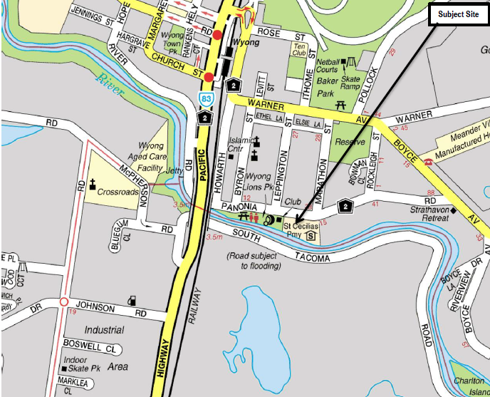
Figure 1. Location Plan, Six Maps.

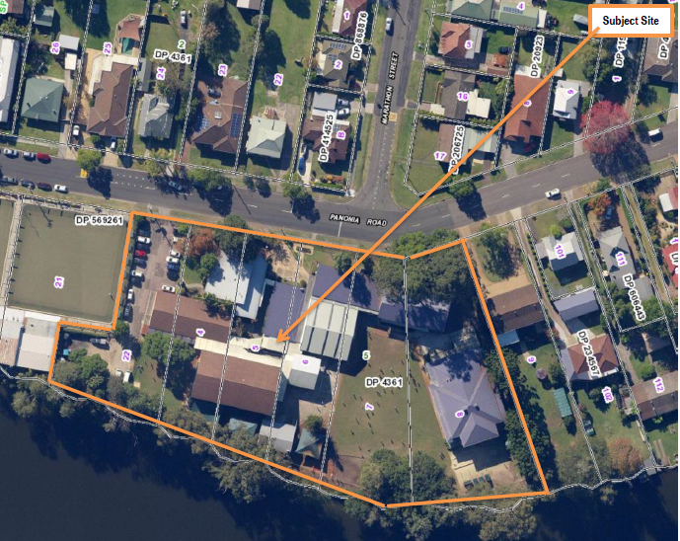
Figure 2. Aerial, Six Maps
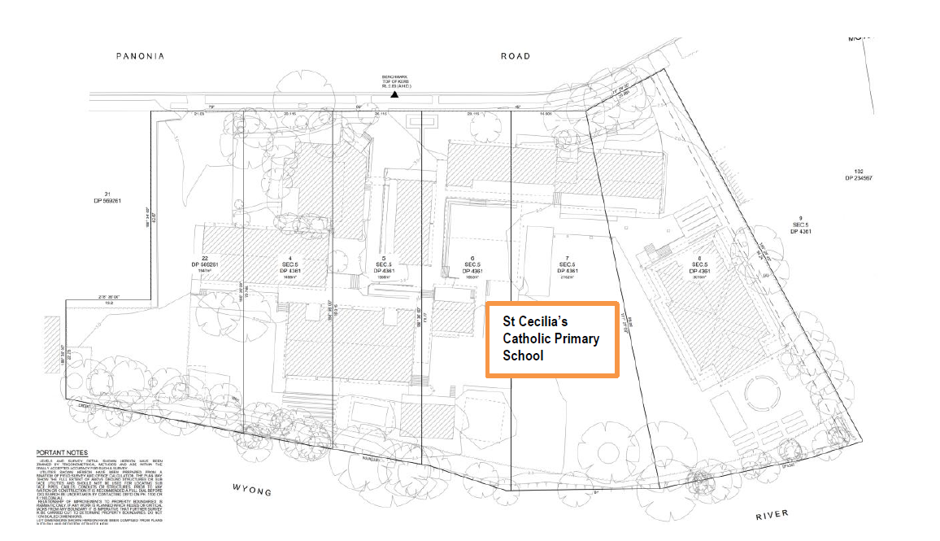
Figure 3. Survey Plan, Mepstead and Associates.

Figure 4. View south from Panonia Road towards St Cecilia’s Primary School.

Figure 5. View south towards St Cecilia’s Primary School from the intersection of Panonia Road and Marathon Street.
Figure 6. Streetscape view east along Panonia Road.
Figure 7. View West from Panonia Road to Wyong Bowling Club, directly adjoining St Cecilia’s Primary School.

THE PROPOSAL AND BACKGROUND

The development application seeks consent for both the demolition and construction of building works as follows:

- carry out on-site preparation works, including the demolition of four (4) existing classroom buildings, shown on the architectural drawings as Buildings A, C, G (demountable) and I

- demolition of ancillary structures, including access stairs and ramps

- carry out minor excavation works, including the removal of existing Astro turf

- provision is made for new Astro turf

- removal of 4 trees as shown on plans

- construction of a new two storey school building facing Panonia Road with interactive outdoor learning areas, stairs, lift and amenities (ground level)

- the new two storey classroom/interactive outdoor learning building fronting Panonia Road has an overall length of approximately 55m

- provision of six attached generously sized Level 1 classrooms with outdoor learning area and amenities over ground floor interactive outdoor learning areas (under croft)

- generous sized verandah that links classrooms to outdoor learning area, stairs, lift and amenities

- new amenities

- new artificial turf with both tree and low level plantings next to the COLA Building

- new landscaping

- new outdoor seating, tiered learning areas, stairs and access ramps

- new retaining walls

- introduce new stormwater strategy to best practice standards, including water harvesting

- introduction of new landscaped outdoor seating terraces

- provide new landscaped pathways

- new planter boxes

- two types of metal louvres on the façade of new teaching building.
There will be no increase in student or teaching numbers.

New teaching block and amenities

Ground level
- two-level single teaching block facing Panonia Road
- new paving and pathway works around the new building
- new amenities on eastern side of new teaching building
- new amenities, inclusive of toilets and wash basins
- new stairs allowing easy access to new interactive outdoor learning area below level 1 (under croft)
- new landscaping in front setback, west of new teaching building and new landscaped pad at rear of Building E
- new artificial turf with trees to create a passive recreational area
- new rainwater collection tanks
- new amenities, plant, services room, resources room and,
- new landscaped planter boxes around pathways, access ramps and tiered learning areas.

Level One
- six new adjoining classrooms with glazed windows and doors
- generous sized verandah with glass balustrading and associated stairs and lift
- lockers
- louvres on facade and
- new amenities, plant, services room, resources room.

Roof
- Ventilation stacks and
- Metal skillion roof.

Figure 8. Northern elevation, addressing Panonia Road.

Figure 9. Eastern elevation

Figure 10. Section.

The existing school operates from Monday to Friday, 8.00 am to 4.00 pm inclusive. These hours are not proposed to change.

Table 1. Development data
Control | Proposed
Site area | 11,854sqm
GFA | Not applicable to this site, although the total GFA sought is 770sqm.
FSR | Not applicable to this site
Height of Building | Not applicable to this site
Clause 4.6 Request | Nil sought
Landscaped area | Landscape plan submitted
Car parking spaces | 23 On site car spaces
Setbacks to Panonia Road | 6.010m, 7.980m to 18.560m

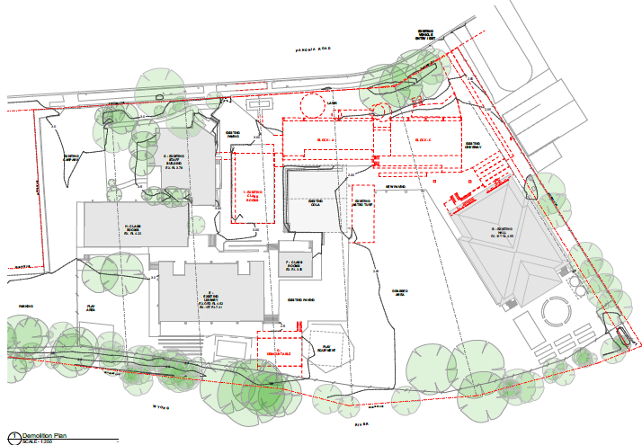
Figure 11. Demolition Plan

Figure 12. Proposed north/west perspective (entry view)

Figure 13. Proposed southern perspective (within the site)
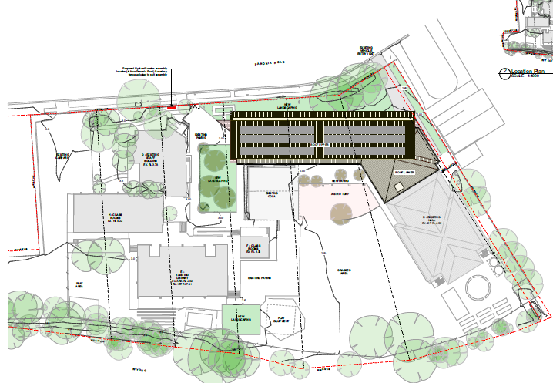

Figure 14. Proposed site plan.

BACKGROUND

The development application was lodged on the Planning Portal on 31 March 2023 and accepted by Central Coast Council on 18 April 2023.

A chronology of the development application since lodgement is outlined below including the Panel’s involvement with the application:

Table 2. Chronology of the DA
Date | Event
31 March 2023 | DA registered on the Planning Portal
18 April 2023 | DA accepted by Central Coast Council
20 April 2023 | DA allocated to assessment planner
20 April to 4 May 2023 | Exhibition of the application
20 April 2023 | DA referred to external agencies
15 May 2023 | Site inspection
6 June 2023 | GTAs from NSW RFS received
14 June 2023 | Kick off briefing held with the Panel
29 June 2023 | GTAs from Department of Planning and Environment – Water received
28 July 2023 | Applicant response to draft conditions

SITE HISTORY

A search of Council’s electronic records show following applications were previously considered in relation to the subject site:

- DA/973/1993 approved on 2 December 1993 for an awning over the school assembly area

- BA/3988/1993 approved on 7 February 1994 for an assembly area awning

- BA/573/1996 approved on 22 March 1996 for the installation of a 1.8m satellite dish for educational use

- DA/197/1996 approved on 22 March 1996 for the installation of a 1.8m satellite dish for educational use

- TA/919/1996 approved on 21 May 1996 for the pruning of trees on the property

- BA/3288/1997 approved on 17 December 1997 for the conversion of the canteen to a classroom

- DA/844/1997 approved on the 17 December 1997 for the conversion of the canteen to a classroom

- TA/1234/1998 approved on 27 November 1998 to prune one tree
- DA/658/2001 approved on 10 May 2011 for the alteration of classroom to a canteen, meeting room, walkway, and W/C in Block G

- TA/203/2001 refused on 14 May 2001 for the removal of six trees

- DA/2832/2002 approved on 16 January 2003 for educational facility alterations and additions

- TA/234/2009 completed on 16 June 2009 for the removal of seven trees and pruning of seven trees

- DA/829/2009 approved on 27 October 2009 for the multi-purpose hall and alterations to the existing classroom building (Block D)

- SCC/71/2010 approved on 10 August 2020 for the multi-purpose hall and alterations to the existing classroom building (Block D); and

- TA/82/2013 approved with variations on 22 February 2013 for the removal of a tree.

STATUTORY CONSIDERATIONS

When determining a development application, the consent authority must take into consideration the matters outlined in Section 4.15(1) of the of the Environmental Planning and Assessment Act 1979 (‘EP&A Act’). These matters as are of relevance to the development application include the following:

- the provisions of any environmental planning instrument, proposed instrument, development control plan, planning agreement and the regulations
(i) any environmental planning instrument, and
(ii) any proposed instrument that is or has been the subject of public consultation under this Act and that has been notified to the consent authority (unless the Planning Secretary has notified the consent authority that the making of the proposed instrument has been deferred indefinitely or has not been approved), and
(iii) any development control plan, and
(iiia) any planning agreement that has been entered into under section 7.4, or any draft planning agreement that a developer has offered to enter into under section 7.4, and
(iv) the regulations (to the extent that they prescribe matters for the purposes of this paragraph), that apply to the land to which the development application relates,
- the likely impacts of that development, including environmental impacts on both the natural and built environments, and social and economic impacts in the locality,
- the suitability of the site for the development,
- any submissions made in accordance with this Act or the regulations,
- the public interest.

These matters are further considered below.

The proposal is Integrated Development (s4.46) with General Terms of Approval required from NSW Rural Fire Service and Department of Planning and Environment -Water.
ENVIRONMENTAL PLANNING INSTRUMENTS, PROPOSED INSTRUMENT, DEVELOPMENT CONTROL PLAN, PLANNING AGREEMENT AND THE REGULATIONS

The relevant environmental planning instruments, proposed instruments, development control plans, planning agreements and the matters for consideration under the Regulation are considered below.

SECTION 4.15(1)(a)(i) – PROVISIONS OF ENVIRONMENTAL PLANNING INSTRUMENTS

The following EPI’s are relevant to the application:

Table 3. Summary of applicable EPI’s:
EPI | Matters for Consideration | Comply (Y/N)
State Environmental Planning Policy (Planning Systems) | Chapter 2: State and Regional Development  Section 2.19(1) declares the proposal regionally significant development pursuant to Clause 5 of Schedule 6 as it comprises private infrastructure and community facilities over $5M. | Yes
State Environmental Planning Policy (Biodiversity and Conservation) 2021 | No native vegetation is proposed to be removed or impacted by the proposed development.  No koalas or koala habitat is affected or impacted by the proposed development. | Yes
State Environmental Planning Policy (Resilience and Hazards) 2021 | The site is located within a coastal environment and coastal use area and is deemed satisfactory with regards to Clauses 2.10 and 2.11 of the SEPP.  The current and historic land uses are not potentially contaminating, therefore the site is deemed satisfactory with regards to the relevant provisions of the SEPP and considered to be suitable for the continued use as an educational facility. | Yes
State Environmental Planning Policy (Transport and Infrastructure) 2021 | The proposed development does not front a classified road.  The proposed development is not increasing student numbers and therefore referral to TfNSW is not required under Clause 2.121 of the SEPP. | Yes
Proposed instruments | Not applicable in this instance. | N/A
CCLEP 2022 | Clause 2.3 – Permissibility and zone objectives | Yes
WLEP 2013 | Clause 7.3 – Floodplain risk management | Yes
CCDCP | Chapter 2.13 – Transport and Parking  Chapter 2.14 – Waste Management  Chapter 2.17 – Character and Scenic Quality  Chapter 3.1 – Floodplain Management  Chapter 3.5 – Tree and Vegetation | Yes

Section 4.47 – Development that is Integrated Development (EP&A Act 1979)

The site is designated as Bushfire Prone Land as shown in the below figure.

Figure 15. Extract from the Central Coast Council Bushfire Prone Land Map.

The subject development also relates to a listed Special Fire Protection Purpose (SFPP) located on bushfire prone land and is therefore classified as integrated development under Section 4.46 of the EP&A Act. The development is also captured under Section 100B of the Rural Fires Act 1997 and must obtain a Bush Fire Safety Authority from the Commissioner of the NSW Rural Fire Service.

Accordingly, the application is accompanied by a Bushfire Assessment Report, prepared by Building Code and Bushfire Hazard Solutions Pty Limited and dated 9 December 2022, which provides an independent bushfire assessment together with appropriate recommendations for both new building construction and bushfire mitigation measures considered necessary having regard to construction within a designated ‘bushfire prone area’.

In accordance with s.4.46(1) of the Environmental Planning and Assessment Act 1979, the development application and accompanying bushfire report were referred to the NSW Rural Fire Service seeking general terms of approval. The NSW RFS issued General Terms of Approval under Division 4.8 of the EP&A Act 1979 and a Bush Fire Safety Authority under section 100B of the Rural Fires Act 1997 was issued on Tuesday 6 June 2023, subject to recommended conditions.

Section 4.47, subsections (1), (2) and (3) of the EP&A Act 1979 state as follows:

4.47 Development that is integrated development

(1) This section applies to the determination of a development application for development that is integrated development.
(2) Before granting development consent to an application for consent to carry out the development, the consent authority must, in accordance with the regulations, obtain from each relevant approval body the general terms of any approval proposed to be granted by the approval body in relation to the development. Nothing in this section requires the consent authority to obtain the general terms of any such approval if the consent authority determines to refuse to grant development consent.
(3) A consent granted by the consent authority must be consistent with the general terms of any approval proposed to be granted by the approval body in relation to the development and of which the consent authority is informed. For the purposes of this Part, the consent authority is taken to have power under this Act to impose any condition that the approval body could impose as a condition of its approval.
Having regard for the above, the consent authority can be satisfied that General Terms of Approval have been obtained from the NSW Rural Fire Service (s.4.47(2)), and that the draft conditions of consent are consistent with the General Terms of Approval that have been granted.
Controlled Activity Approval -Water Management Act 2000
In accordance with s.4.46(1) of the Environmental Planning and Assessment Act 1979, the application has been nominated as being integrated development for the purposes of requiring a controlled activity approval and has been referred to the Department of Planning & Environment -Water for their Approval, as the proposed development is within 40m of a mapped watercourse.
DPE Water (29 June 2023) have issued their General Terms of Approval (s.4.47(2)), and the consent authority can be satisfied that the draft conditions of consent are consistent with the General Terms of Approval that have been granted.
State Environmental Planning Policy (Planning Systems) 2021

Chapter 2: State and Regional Development

The proposal is regionally significant development pursuant to Section 2.19(1) as it satisfies the criteria in Clause 5 of Schedule 6 of the Planning Systems SEPP as the proposal is development for the purposes of an educational establishment that has a capital investment value of more than $5 million. Accordingly, the Hunter and Central Coast Regional Planning Panel is the consent authority for this application.

The proposal is consistent with this Policy.

State Environmental Planning Policy (Resilience and Hazards) 2021

The relevant provisions of the SEPP are addressed as follows:

Chapter 2: Coastal Management

The aims of Chapter 2 are to be considered when determining an application within Coastal Management Areas. The subject site is located within a coastal environment area and a coastal use area. Sections 2.10 and 2.11 are to be taken into consideration by the consent authority when it determines a development application to carry out development on land to which this SEPP applies. The proposed development has satisfactorily addressed the matters for consideration outlined in sections 2.10 and 2.11. A compliance table for this SEPP has been included within Attachment B.
In accordance with section 2.12 the proposed development is not likely to cause any increased risk of coastal hazards on the subject site or adjoining lands, and there is no relevant certified coastal management program that needs to be considered as per s.2.13.

Having regard for Sections 2.10 (2), 2.11(2) and 2.12 of State Environmental Planning Policy (Resilience & Hazards) 2021, the Panel can be satisfied that the proposed development is designed, sited, and will be managed to avoid an adverse impact referred to in s.2.10(1) and s.2.11(1), the bulk, scale and size of the proposed development is satisfactory having regard for the surrounding coastal and built environment (s.2.11(3)), and the development is not likely to cause increased risk of hazards on the subject site or other land (s.2.12).

Chapter 4: Remediation of Land

The provisions of Chapter 4 have been considered in the assessment of the development application and requires consent authorities to consider whether the land is contaminated, and if the land is contaminated, it is satisfied that the land is suitable in its contaminated state (or will be made suitable, after remediation) for the purpose for which the development is proposed to be carried out.

The site has historically been used as a school since 1916 and its past use is unlikely to have resulted in contamination of the site. The proposed development is to replace existing building stock in the same location.

A Geotechnical Report, prepared by Crozier Geotechnical Consultants dated June 2023, was prepared and identifies that there is expected to be negligible impact to the local hydrology with no bulk excavation proposed to extend below the water table, precluding the implementation of any dewatering regime. Further, potential Acid Sulfate Soils (PASS) are not present within the site and therefore will not be intersected within the envelope of the proposed works.

In accordance with s.4.6, the Panel can be satisfied that the land is suitable for the proposed development, a preliminary site investigation is not required in this instance and that based on information before council, the land has not been previously used for a purpose referred to in Table 1 of the contaminated land planning guidelines.

State Environmental Planning Policy (Transport and Infrastructure) 2021

Chapter 3 Educational Establishments/Design Quality Principles

Clause 3.11 of the SEPP requires consideration of Planning for Bush Fire Protection before carrying out the development in an area that is bush fire prone land.

In this instance, the site is identified as bushfire prone land due to the vegetation buffer at the rear. Further, Schools are listed as Special Fire Protection Purpose (SFPP) under section 100B(a) of the Rural Fires Act 1997. As previously discussed, the application was referred to the NSW RFS who have issued a Bushfire Safety Authority and General Terms of Approval for the proposed development.

Clause 3.35 of the SEPP requires a consent authority to take into consideration the design quality of the development in accordance with the design quality principles set out in Schedule 8 of the SEPP. The seven design principles are set out in the following table.

Table 4. Design Quality Principles and Assessment
Design Quality Principle | Design Response | Compliance
Principle 1 - context, built form and landscape.  Schools should be designed to respond to and enhance the positive qualities of their setting, landscape and heritage, including Aboriginal cultural heritage. The design and spatial organisation of buildings and the spaces between them should be informed by site conditions such as topography, orientation and climate.  Landscape should be integrated into the design of school developments to enhance on-site amenity, contribute to the streetscape and mitigate negative impacts on neighbouring sites.  School buildings and their grounds on land that is identified in or under a local environmental plan as a scenic protection area should be designed to recognise and protect the special visual qualities and natural environment of the area and located and designed to minimise the development’s visual impact on those qualities and that natural environment. | The proposed classroom building fronts Panonia Road and is designed to respond to key site considerations including the slope of the site, solar access, provision of open space and impacts upon surrounding properties and other buildings and amenity areas within the site.  The proposed building mass is sited and positioned to address Panonia Road and enhance the streetscape, promoting passive and casual surveillance.  The length of the proposed building mass is broken down by providing articulation, an openness in ground floor design and circulation (including ground floor open learning areas, staircases and walkways).  The positioning of the building within the site is also based around accessibility and disability requirements, improving access through the site. The inclusion of lifts within the multi-level building ensure equitable access for students, teachers and visitors.  Overall, the built form and proposed landscape design integrates with the existing site and will result in a positive connection with the wider community, both in its urban and natural context. | Yes
Principle 2 - sustainable, efficient and durable.  Good design combines positive environmental, social and economic outcomes. Schools and school buildings should be designed to minimise the consumption of energy, water and natural resources and reduce waste and encourage recycling.  Schools should be designed to be durable, resilient and adaptable, enabling them to evolve over time to meet future requirements. | The proposed design has taken advantage of the natural contours and enhances the natural ecosystem of mature vegetation within the primary setback and the heavily vegetated corridor at the rear of the site. Rainwater will be collected in large storage tanks for reuse back into the school. Energy efficient mechanical systems and highly efficient water fixtures and fittings are proposed to reduce consumption. Solar roof panels proposed will be installed to provide efficient energy to the school.  The proposed landscape design focuses on the integration of people, nature and learning across the whole site through a centralised courtyard as a social gathering place. The southern courtyard for recreational activities will also provide for active and passive recreational activities. The classrooms face north with generous sized windows to encourage solar access to all parts of the proposed learning spaces and support cross flow ventilation and air movement between and throughout the development. The ground floor open undercroft area will also provide a protected and communal gathering space for students.  The floor plates provide opportunities for views in all directions across the school. Roof overhangs and sun shading devices provide appropriate solar protection.  The Applicant submits that the materials and finishes selected for the external façade treatment are robust and durable, in line with the NSW Department of Education requirements. The focus on sustainability is balanced with economic prosperity, social responsibility and environmental sensitivity. The proposal seeks to focus on reimagining and transforming the school into a 21st Century learning environment that supports the growing population. | Yes
Principle 3 - accessible and inclusive.  School buildings and their grounds should provide good wayfinding and be welcoming, accessible and inclusive to people with differing needs and capabilities.  Note — Wayfinding refers to information systems that guide people through a physical environment and enhance their understanding and experience of the space.  Schools should actively seek opportunities for their facilities to be shared with the community and cater for activities outside of school hours. | The overall design of the building and outdoor recreational area has a deliberate focus on a connected learning community with central student and staff support spaces surrounding by general learning units. A seamless circulation pathway and ramps provides horizontal, clear and direct access to all learning spaces and core student facilities.  Through a combination of stairs, ramps and lifts both externally and internally, all areas are accessible to both students and teachers. Circulation commences from the main access point into the site, easily connecting and navigating through all buildings, supporting simple wayfinding logic across all spaces.  The internal design will incorporate graphics and signage to each teaching classroom to promote a sense of purpose, place and belonging for students. The design focuses on strong connection between people and spaces through spatial planning and transparency to engage both students and staff in a collaborative environment.  The proposed development does not lend itself to being used by the community outside of normal school hours. The development and small passive recreational areas are spaces that must be locked up after hours to avoid any anti -social behaviour. | Yes
Principle 4 - health and safety.  Good school development optimises health, safety and security within its boundaries and the surrounding public domain, and balances this with the need to create a welcoming and accessible environment. | The front boundary gates will be open to allow public entry during normal school hours.  The existing administration building will retain passive surveillance over the public forecourt. Surrounding the site, standard fencing will ensure ongoing security for the students. All roadways and parking areas are not proposed to change and will remain fenced off from student access to maintain safety and security.  Current delivery access off the street will remain via Panonia Road. This area will also be fenced to keep students safe from vehicle movements. External walls to all teaching spaces promote natural daylight and cross flow ventilation. Openable windows, glass doors and louvres at low and high levels will promote convection and air movement, circulating fresh air through internal environments to support healthy learning spaces. Open planned learning environments will support collaborative learning opportunities with external environments open and visually connected.  The proposed development ensures view retention in a southerly direction overlooking the central courtyard. Direct access from internal leaning spaces to deep verandahs and deck areas provide opportunities for learning to extend to the outdoors.  Landscaped areas with a variety of settings also encourage learning to take place in the outdoors. Large roof canopies over circulation pathways will ensure protection from adverse weather conditions and seamless connection between facilities. They will provide protected areas for students who seek refuge during periods of extreme weather conditions and safe access in and around school grounds. | Yes
Principle 5 - amenity.  Schools should provide pleasant and engaging spaces that are accessible for a wide range of educational, informal and community activities, while also considering the amenity of adjacent development and the local neighbourhood.  Schools located near busy roads or near rail corridors should incorporate appropriate noise mitigation measures to ensure a high level of amenity for occupants.  Schools should include appropriate, efficient, stage and age appropriate indoor and outdoor learning and play spaces, access to sunlight, natural ventilation, outlook, visual and acoustic privacy, storage and service areas. | The proposed new development has been sited to respond to and comply with all site constraints and investigations undertaken. The building utilises the cross fall to assist in the reduction of overall building height, form and scale, appropriate for a low density residential zone.  The proposed development has limited the amount of hard landscaping elements which also assists with the everyday wellbeing of students.  The proposed design promotes a welcoming and inviting public forecourt and encourages school and community interaction. The variety of spaces and learning settings, both internally and externally, will support the variety of needs of students and staff alike. The arrangement of the core facilities and centralised teaching pods, encourage integration and collaboration with activity based learning. | Yes
Principle 6 - whole of life, flexible and adaptive.  School design should consider future needs and take a whole-of-life-cycle approach underpinned by site wide strategic and spatial planning. Good design for schools should deliver high environmental performance, ease of adaptation and maximise multi-use facilities. | The development requires the demolition of existing buildings and has considered future expansion opportunities in a way that minimises potential interruptions of any future developments.  Future expansion of the site can occur without impacting on the outdoor spatial requirements across the school.  The internal floor plates are designed to be fitted out with minimal impact to the building structure. The predominant use of loose and moveable furniture in lieu of fixed joinery units will also enable learning spaces to be flexible for teaching and learning changes into the future. The open planned and futures focused learning environment focuses on the shared use of space that can be further adapted to suit varying teacher and learning styles. | Yes
Principle 7- aesthetics.  School buildings and their landscape setting should be aesthetically pleasing by achieving a built form that has good proportions and a balanced composition of elements. Schools should respond to positive elements from the site and surrounding neighbourhood and have a positive impact on the quality and character of a neighbourhood.  The built form should respond to the existing or desired future context, particularly, positive elements from the site and surrounding neighbourhood, and have a positive impact on the quality and sense of identity of the neighbourhood. | The overall design is sympathetic to the current residential neighbourhood has a strong presence in the community and so the proposal attempts to a deliver a positive and welcoming expression. The built form does not dominate the streetscape.  The roof is intended to replicate a tree canopy, inspired by the existing trees and landscaping on site. The low profile roof features keep the overall height to a minimum, and in proportion with nearby residential dwellings. The proposed development is well setback from Panonia Street to minimise potential impacts to the adjoining residential property.  A solid base grounds the development, where light weight upper cladding helps break up the teaching façade.  Native plantings, turfed areas and the retention of existing trees reflect the natural surrounds o the region. The overall design reflects the values of the community to celebrate and enhance the existing biodiversity, giving a sense of pride and place in the community. | Yes

State Environmental Planning Policy (Biodiversity and Conservation) 2021

Chapter 4: Koala habitat protection 2021

There is no approved koala plan of management which applies to the site and no koalas are recorded to have occurred on the site. In accordance with Section 4.9(3) of the Biodiversity Conservation SEPP 2021, the application is considered to have no impact on koalas or koala habitat.

Central Coast Local Environmental Plan 2022

The relevant local environmental plan applying to the site is the Central Coast Local Environmental Plan 2022 (CCLEP 2022). The aims of the LEP include:

1.2 Aims of Plan
(1) This Plan aims to make local environmental planning provisions for land in the Central Coast in accordance with the relevant standard environmental planning instrument under section 3.20 of the Act.
(2) The particular aims of this Plan are as follows—
(aa) to protect and promote the use and development of land for arts and cultural activity, including music and other performance arts,
(a) to foster economic, environmental and social well-being so that the Central Coast continues to develop as a sustainable and prosperous place to live, work and visit,
(b) to encourage a range of housing, employment, recreation and services to meet the needs of existing and future residents of the Central Coast,
(c) to promote the efficient and equitable provision of public services, infrastructure and amenities,
(d) to provide for a range of local and regional community facilities for recreation, culture, health and education purposes,
(e) to conserve, protect and enhance the natural environment of the Central Coast, incorporating ecologically sustainable development,
(f) to conserve, protect and enhance the environmental and cultural heritage of the Central Coast,
(g) to minimise risk to the community in areas subject to environmental hazards, including flooding, climate change and bush fires,
(h) to promote a high standard of urban design that responds appropriately to the existing or desired future character of areas,
(i) to promote design principles in all development to improve the safety, accessibility, health and well-being of residents and visitors,
(j) to concentrate intensive land uses and trip-generating activities in locations that are most accessible to transport and centres,
(k) to encourage the development of sustainable tourism that is compatible with the surrounding environment.
The proposal is consistent with these aims of the plan as the proposal provides educational infrastructure, which is consistent with aims aa, a, c, d, g, h, I, and j above.

Zoning and Permissibility

The site is zoned is R2 – Low Density Residential pursuant to Clause 2.2 of the CCLEP 2022.

Figure 16. Land zoning map.

The proposed development satisfies the definition of ‘educational establishment’ which is a permissible use with consent in the Land Use Table in Clause 2.3.

The zone objectives include the following, pursuant to the Land Use Table in Clause 2.3:

- To provide for the housing needs of the community within a low-density residential environment.
- To enable other land uses that provide facilities or services to meet the day to day needs of residents.
- To encourage best practice in the design of low-density residential development.
- To ensure that non-residential uses do not adversely affect residential amenity or place unreasonable demands on services.
- To maintain and enhance the residential amenity and character of the surrounding area.

The proposed development provides for modifications to an existing, well established primary school that will have no impact upon the surrounding low density residential neighbourhood, the adjoining Wyong Bowling Club or the special features and aesthetic values of the Wyong River which abuts the educational establishment.

General Controls and Development Standards (Parts 2, 4, 5 and 6)

The CCLEP 2022 contains controls relating to development standards, miscellaneous provisions and local provisions. The relevant controls to the proposal are further set out in Table 5 below.

Table 5. Consideration of LEP controls.
Control | Requirement | Proposal | Comply
Minimum subdivision lot size  (clause 4.1) | N/A | N/A | N/A
Height of Buildings (clause 4.3(2) | N/A | 8.8m (RL 11.800 – RL 3.00) | N/A
Floor Space Ratio  (clause 4.4(2) | N/A | 770sqm | N/A
Heritage  (clause 5.10) | N/A | N/A | N/A
Bushfire Hazard Reduction  (clause 5.11) | N/A | N/A | N/A
Flood Planning  (clause 5.21) | Development consent must not be granted to development on land the consent authority considers to be within the flood planning area unless particulars are demonstrated to be satisfied. | Discussed below. | Yes
Acid Sulfate Soils (clause 7.1) | Development consent is required for the carrying of works described in the table in subclause 7.1(2). | Discussed below. | Yes
Limited development on foreshore area  (clause 7.3) | Part of the site is identified as foreshore area. The proposed development however does not seek to undertake the erection of a building in the identified foreshore area. | Yes | Yes
Essential Services  (clause 7.6) | The following essential services remain available to the site – the supply of water, electricity, disposal and management of sewage, stormwater drainage, suitable vehicular access and the collection and management of waste. | Yes | Yes
Transitional provision for floodplain risk management (clause 7.23) | Wyong LEP clause 7.3 continues to apply and states that development consent must not be granted for an educational establishment unless the consent authority is satisfied that the development will not in flood events exceeding the flood planning level, affect the safe occupation of and evacuation from the land. | Discussed below. | Yes

Clause 5.21 – Flood Planning

In accordance with Clause 5.21(2), development consent must not be granted to development on land the consent authority considers to be within the flood planning area unless the consent authority is satisfied the development –

- Is compatible with the flood function and behaviour on the land, and
- Will not adversely affect flood behaviour in a way that results in detrimental increases in the potential flood affectation of other development or properties, and
- Will not adversely affect the safe occupation and efficient evacuation of people or exceed the capacity of existing evacuation routes for the surrounding area in the event of a flood, and
- Incorporates appropriate measures to manage risk to life in the event of a flood, and
- Will not adversely affect the environment or cause avoidable erosion, siltation, destruction of riparian vegetation or a reduction in the stability of river banks or watercourses.

The application is accompanied by a Flood Assessment, prepared by Molino Stewart and dated 18 April 2023. The Assessment sets out flood advice detailing the flood constraints for the site and has been reviewed by Council’s Development Flooding Engineer who has confirmed that the proposed development is more compatible with the flood function and behaviour on the land than the existing arrangement because of the removal of the existing building obstructions at ground level and the replacement with a less obstructive undercroft area. This allows for a more efficient flood storage compared to the existing situation on site.

Council’s Development Flooding Engineer has also confirmed that there is an existing evacuation issue on the site, however this proposal will not result in any additional classrooms or people on site and does not introduce increased risks for evacuation and/or reliance upon emergency services due to the existing use and no proposed increase in student or staff numbers. The proposed flood emergency response plan is expected to assist in evacuation in this instance (Conditions 5.12 and 6.5).

Both Council’s Development Engineer and Development Flooding Engineer are satisfied that the proposal does not increase the risk to life or impact to the existing evacuation requirements and the design reduces the impact on flood behaviour, hence the proposal is supported. In this regard, the Panel can be satisfied that the proposed development, subject to conditions:

(a) is compatible with the flood function and behaviour on the land, and
(b) will not adversely affect flood behaviour in a way that results in detrimental increases in the potential flood affectation of other development or properties, and
(c) will not adversely affect the safe occupation and efficient evacuation of people or exceed the capacity of existing evacuation routes for the surrounding area in the event of a flood, and
(d) incorporates appropriate measures to manage risk to life in the event of a flood, and
(e) will not adversely affect the environment or cause avoidable erosion, siltation, destruction of riparian vegetation or a reduction in the stability of river banks or watercourses.
Clause 7.1 – Acid Sulfate Soils

The site is identified as Class 3 Acid Sulfate Soils and the application is accompanied by a Geotechnical Investigation prepared by Crozier Geotechnical Consultants dated 26 June 2023. The consultant conducted a walk over inspection and mapping including photographic records, and geological/geomorphological mapping. The consultant additionally conducted three boreholes (BH1 to the east of the site, BH2 to the south of the site, and BH3 to the north-west of the site) and four dynamic cone penetrometer (DCP) testing (DCP1 to the north-east of the site, DCP2 and DCP3 to the north of the site and DCP4 to the north-west of the site), providing a holistic overview of the sites soil profile.

As a result of the testing and with no bulk excavation proposed to extend below the water table, the consultant has concluded that potential Acid Sulfate soils (PASS) are not present within the site and will therefore not be intersected within the envelope of proposed works. Therefore, a detailed ASS management plan is not required for this proposed development.

The application was referred to Council’s Environmental Health Officer who reviewed the proposal and determined the Geotechnical Investigation to be acceptable, subject to recommended conditions imposed on any consent granted for the proposed development.

Clause 7.6 -Essential Services

The consent authority can be satisfied that the proposed development has adequate essential servicing available to the development having regard for water, sewer, electricity, stormwater drainage, waste collection and vehicular access.

Clause 7.23 – Transitional provision for floodplain risk management

In a PMF event, safe occupation and efficient evacuation from the site may be difficult, although recognised as an existing issue. Both Council’s Flood Engineer and the Applicant’s Consultant Molino Stewart agree that the proposed development is more compatible with the flood function and behaviour on the land than the existing arrangement due to the removal of ground level building obstructions and replacement with a less obstructive undercroft area. This will allow for more efficient flood storage compared to the existing situation on site.

Provided that the building is designed and constructed to remain stable when exposed to flood and debris, it may improve the safety of anyone who fails to evacuate, prior to the development becoming isolated in a PMF.

Conditions are recommended relating to safe occupation and efficient evacuation in accordance with the requirements of this Clause (Conditions 2.4 and 6.5).

SECTION 4.15(1)(a)(ii) – PROVISIONS OF ANY PROPOSED INSTRUMENTS

There are no draft instruments for consideration in this regard.

SECTION 4.15(1)(a)(iii) – PROVISION OF ANY DEVELOPMENT CONTROL PLAN

Central Coast Development Control Plan 2022

Chapter 2.13 - Transport and Parking
Table 6.
Clause | Required | Comment | Compliance
2.13.3 | A traffic management plan is required where a variation to carparking is proposed. | The proposal does not increase the number of students or staff and therefore, there is no increase in demand for parking. | Yes
 | A construction management plan is required while work is being carried out on site. | To be imposed as a condition of consent. | Yes
2.13.3.2 | Carparking – educational establishments. | The proposal does not result in the increase in number of students or staff and there is no increase in demand for parking. The existing bus stop and kiss and ride facilities will be retained. | Yes
2.13.3.7 | Parking and access for the disabled. | 1 existing on-site accessible space provided. Discussed below. | No – discussed below.

Roads, access, traffic and parking

The site currently contains an Educational Establishment (Primary School), fronting Panonia Road, and is serviced via an approx. 4.2m (at kerb) to 4.0m (at boundary) wide Vehicle Access Crossing (VAC) at the western end of the site frontage (into the on-site staff car parking area and waste storage areas), an approx. 3.5m wide VAC in the centre of the frontage (currently fenced off, with an adjacent gate expected to be used for pedestrian access), and an approx. 4.5m wide VAC at the eastern end of the frontage.

Fronting the site is sealed carriageway, with centreline and School Crossing markings, upright kerb, formed grass verge, 1.2m wide pedestrian footpath, street signage (including a Bus Zone across the west of the frontage, a “No Stopping” zone across the centre of the frontage around the School Crossing, and a No Parking zone across the east of the site frontage), and overhead and underground utilities and services. A road intersection, between Panonia Road and Marathon Street is located opposite the centre/eastern frontage of the site.

The proposed development does not seek to alter the existing access arrangements for the site – both for pedestrians or vehicles including parking arrangements for 22 standard parking spaces, one accessible parking space and servicing arrangements.

The existing accessible parking space does not comply however with AS2890.6:2009 – Offstreet parking for people with disabilities. The accompanying Access Report raises concern in relation to this parking space and the proximity/accessibility of this space to the new proposed building. Condition 2.6(a) is recommended for this parking space to be updated to comply with the current requirements of AS2890.6. Condition 2.5 is also recommended for lighting to be provided to the existing carpark.

Chapter 2.14 – Waste Management

A Waste Management Plan has been submitted for the demolition and construction stages of the proposed development in accordance with the requirements of this Chapter.

The provisions of this Chapter are satisfied in this regard.

Chapter 2.17 – Character and Scenic Quality

The proposed development contributes to the creation of an interesting and attractive building and landscape design by providing an articulated placement of buildings with varied façade treatments. The development is designed to ensure passive surveillance both within the school grounds and to Panonia Road for improved safety and security.

The proposed development is assessed on balance as providing significant public benefit by providing new, purposeful designed learning spaces and amenities that make use of the latest technology and delivery of ESD principles for the varying educational needs of the students.

Overall, the general character and scenic quality of the school and its setting will not significantly change, rather be enhanced by the new building and modifications proposed.

Chapter 3.1 – Floodplain Management

The subject site is subject to significant flooding and the application is accompanied by a Flood Assessment, prepared by Molino Stewart for the purpose of this assessment and as shown below.

Figure 17. Flood extent

The application and associated documentation were referred to Council’s Development Flooding Engineer who has reviewed its content and evaluated the proposal to not result in additional people onsite or vehicles requiring evaluation. There is no net increase in classrooms as a result of the development, rather the existing ground floor classrooms would be demolished and replaced with 6 classrooms and an outdoor learning area at a proposed first floor level of 6.09m AHD.

Council has confirmed that the 1% AEP flood velocity at the proposed building location ranges from 0.05m/s to 0.2m/s. The PMF velocity at the proposed building location ranges from 0.2m/s to 0.5m/s
As the school is currently in operation, there is no proposed change of use which may increase the flood risk to people.

Both Molino Stewart and Council agree that the proposed redevelopment is more compatible with the flood function and behaviour on the land than the existing arrangement because of the removal of the existing building obstructions at ground level and the replacement with a less obstructive under croft area. This allows for the more efficient flood storage compared with the existing situation on site.

Molino Stewart acknowledges that safe occupation and efficient evacuation of the site may be difficult. This is an existing issue. Therefore, Council supports the promotion of a flood emergency response plan for the entire site. Shelter in Place is not recommended by Molino Stewart however the classrooms will be set above the PMF. Provided that the building is designed and constructed to remain stable when exposed to flood and debris, it may improve the safety of anyone who fails to evacuate from the building before it is isolated.

Recommended conditions of consent (Conditions 2.4 and 6.5) have been included and the provisions of Chapter 3.1 are satisfied in this regard.

Chapter 3.5 – Trees and Vegetation

The application is accompanied by an Arboricultural Impact Statement Report, prepared by Mark Bury Consulting, dated 3 February 2023. The Report and associated documentation were referred to Council’s Tree Assessment Officer who has reviewed its content and agreed and confirmed that the four trees located in the proposed building footprint require removal.

Particular reference is made to Tree 1, which the Panel sought to confirm at the Kick Off Briefing on 14 June 2023 that the tree cannot be retained. Further correspondence was received from the Applicant dated 23 June 2023 which refers to pages 9 and 10 of the accompanying Arborist Report. The Report notes Tree 1 as being 10 metres tall with a 5 metre crown spread. The drawing L01 Site Plan and Tree Protection Plan Rev 4 indicates tree 1 as being removed without an SRZ surrounding this tree.

The figures below indicate the tree location on all levels relating to the proposed works with the SRZ on the ground floor using both survey and arborist information. This shows the proposed works require the removal of the tree to accommodate the development sought.

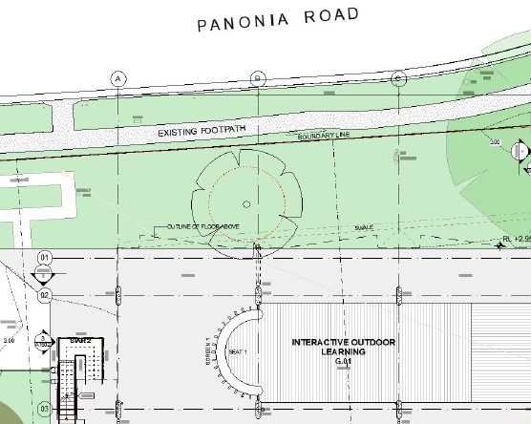
Figure 18. Tree 1 in proximity to proposed ground floor plan.

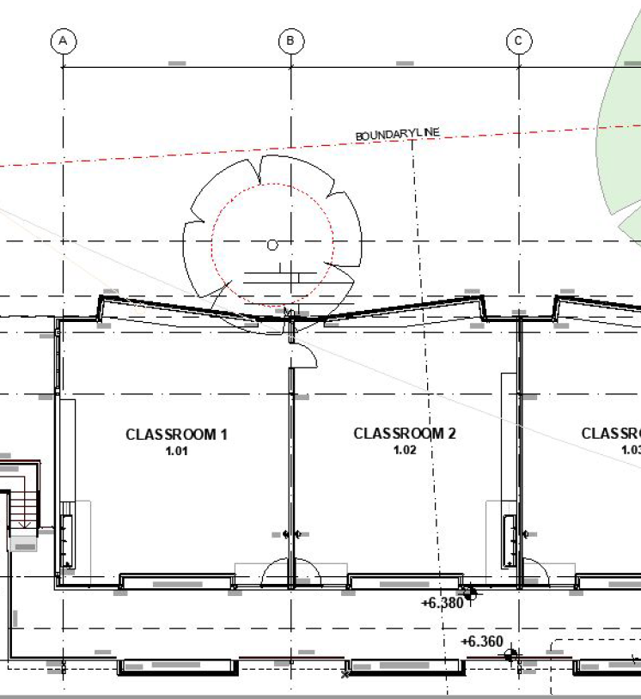

Figure 19. Tree 1 in proximity to proposed first floor plan.

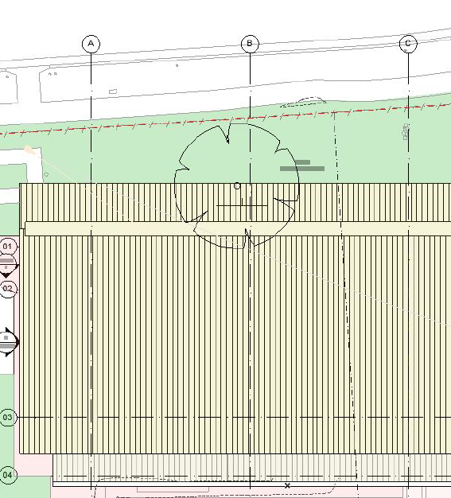
Figure 20. Tree 1 in proximity to proposed roof plan.

Conditions of consent (3.3, 4.8 and 4.9) have been recommended for The provisions of this Chapter are deemed satisfied in this regard.

SECTION 4.15(1)(a)(iiia) – PLANNING AGREEMENTS UNDER SECTION 7.4 OF THE EP&A ACT

There are no planning agreements or draft planning agreements entered into or proposed for the site. No further consideration is required in this regard.

SECTION 4.15(1)(a)(iv) – PROVISIONS OF REGULATIONS

Section 61 of the Environmental Planning and Assessment Regulation, 2021, contains matters that must be taken into consideration by a consent authority in determining a development application, with the following matters relevant to the proposal:

- If demolition of a building is proposed, provisions of AS2601 apply.

The proposed development includes the following:

- On-site preparation works, including the demolition of four existing classroom buildings, each shown on the accompanying architectural plans as Buildings, A, C, G (demountable) & I
- Demolition of ancillary structures, including access stairs and ramps.

Section 62 (consideration of fire safety) and Section 64 (consent authority may require upgrade of buildings) of the 2021 EP&A Regulation are not relevant to the proposal.

The provisions of the 2021 EP&A Regulation have been considered and are addressed in the recommended draft conditions (Condition 4.14).

SECTION 4.15(1)(b) – LIKELY IMPACTS OF DEVELOPMENT

The likely impacts of that development, including environmental impacts on both the natural and built environments, and social and economic impacts in the locality must be considered. In this regard, potential impacts related to the proposal have been considered in response to SEPPs, LEP and DCP controls outlined above and the Key Issues section below.

The consideration of impacts on the natural and built environments includes the following:

- Context and setting – The proposal is considered generally consistent with the context of the school site, in that the proposed building is an appropriate scale, mass, form, and in character with existing and surrounding development. The development has a generous setback to Panonia Road, creating a landscaped outdoor environment that maintains the consistent curtilage of the streetscape whilst maximising outdoor space for learning.

- Public Domain – The proposal will not impact the public domain. There is no public open space adjoining the site except for public road system.

- Utilities – All utilities are available to the site.
- Heritage – The site and adjoining lands do not contain any heritage items.

- Water, soil and air impacts – the site has been used as an educational establishment since 1916 and this past use is unlikely to result in contamination.

- Flora and fauna impacts – The application is accompanied by an Arborist Report, prepared by Mark Bury Consulting, and considers the likely impacts of the proposed tree removal on the site associated with the proposed works. The Arborist has set out mitigation measures to minimise the impact on existing native vegetation and the building footprint and envelope has been designed and sited to maintain all significant trees on site, where possible.

- Noise and vibration – The application is accompanied by an Acoustic Assessment, prepared by Stantec Consultancy, and recommends measures for noise mitigation within the school. The proposed development is able to satisfy best practice standards, having no unreasonable noise impacts to the surrounding residential dwellings.

- Natural hazards – The site is considered bushfire prone due to the existing vegetation buffer separating the site from Wyong River and involves a listed Special Fire Protection Purpose under section 100B(a) of the Rural Fires Act 1997. The application is accompanied by a Bushfire Assessment Report, prepared by Building Code and Bushfire Hazard Solutions Pty Limited, which was referred to the NSW Rural Fire Services (NSW RFS). The NSW RFS has issued General Terms of Approval, subject to conditions (Condition 1.3). This includes development from construction to use in perpetuity being managed in accordance with the requirements of Appendix 4 of Planning for Bush Fire Protection 2019.

The site is impacted by flooding however, the proposed development will result in improved flood behaviour on the site and will not increase the risk to life or impact the existing evacuation requirements. A flood emergency response plan has been conditioned to be developed (Condition 5.12) to address the issue of evacuation of the site. Condition 6.5 requires the flood emergency response plan to be updated annually in consultation with NSW SES.

- Safety, security and crime prevention - Principles of CPTED have been implemented within the proposed development in accordance with the Department of Planning guidelines Crime Prevention and the Assessment of Development Applications, 2001. These Principles are also addressed by way of conditions of consent.

- Social impact – The proposed development will enable the existing primary school to undergo a timely renewal and upgrade, to ensure that existing and future generations within the locality and broader Wyong community have opportunities to high quality education. The proposal will replace aged facilities with contemporary learning facilities, resulting in positive social and economic outcomes.

- Economic impact – The proposed development will generate additional construction employment opportunities, having some local benefit for local businesses.

- Construction – All works on site will be carried out in accordance with statutory construction hours. A CMP will be required and is imposed as a condition of consent that mitigates internal and external impacts during construction (refer condition 3.7).

- Cumulative impacts – The proposed development is unlikely to have any cumulative impacts. It is consistent with applicable planning controls, zoning of the land and the objectives of the R2 – Low Density Residential Zone.

Accordingly, it is considered that the proposed development will not result in any significant adverse impacts in the locality as outlined above.

SECTION 4.15(1)(c) – Suitability of the site

The proposed development fits within the locality of the existing school. There are adequate services, public transport, on-site parking and outdoor playing areas. The risk of bushfire from the adjoining vegetation buffer is mitigated by construction standards and conditions imposed by the NSW RFS.

There are no adjoining land uses which impact upon the development and the surrounding land uses are compatible with the school use.

SECTION 4.15(1)(d) – PUBLIC SUBMISSIONS

There were no public submissions received in response to the notification period. No further consideration is required in this regard.

SECTION 4.15(1)(e) – PUBLIC INTEREST

Approval of the proposed development is in the public interest for the following reasons:

- The proposed development has been prepared having regard to the aims and objectives of Chapter 3: Education and Childcare contained within SEPP (Transport and Infrastructure) 2021 and other State and local environmental planning instruments and generally complies.

- Subject to various mitigation measures recommended by consultants and council’s technical officers, the proposal is deemed to have no negative environmental, social or economic impacts to surrounding residential dwellings or the public domain.

- The proposed development will result in a high quality educational environment for students and teachers alike, that supports and provides efficient and environmentally sustainable facilities.

- The proposed development is designed and sighted to make a positive contribution having regard to the landscaped setting in which the site exists.

- The proposed development remains sympathetic to the existing character of the surrounding residential neighbourhood and respects and maintains privacy to and from neighbouring residential properties.

- The proposed development is considered to offer a safer environment for residents as the design offers better passive surveillance over the public domain.

REFERRALS AND SUBMISSIONS

Agency Referrals and Concurrences

The application was referred to various agencies for comment/concurrence as required by the EP&A Act:

Table 7.
Agency | Concurrence/referral trigger | Comments | Resolved
Concurrence Requirements (s4.13 of the EP&A Act)
Environment Agency Head (Environment, Energy & Science Group within DPIE) | S7.12(2) - Biodiversity Conservation Act 2016 | N/A | N/A
Rail authority for the rail corridor | Section 2.98(3) - State Environmental Planning Policy (Transport and Infrastructure) 2021 | N/A | N/A
Referral/Consultation agencies
Electricity supply authority | Section 2.48 – State Environmental Planning Policy (Transport and Infrastructure) 2021  Development near electrical infrastructure | N/A | N/A
Rail authority | Section 2.97 – State Environmental Planning Policy (Transport and Infrastructure) 2021  Development land that is in or adjacent to a rail corridor. | N/A | N/A
Transport for NSW | Section 2.121 – State Environmental Planning Policy (Transport and Infrastructure) 2021  Development that is deemed to be traffic generating development in Schedule 3. | N/A | N/A
Design Review Panel | Cl 28(2)(a) – SEPP 65  Advice of the Design Review Panel (‘DRP’) | N/A | N/A
Tuggerah Lakes Local Area Command | Crime Prevention Through Environmental Design | The application was referred to the Tuggerah Lakes LAC on 7 June 2023. Correspondence was received dated 14 July 2023 stating CPTED principles stated within the accompanying SEE are to be complied with in addition to consideration of CCTV surveillance. | To be conditioned
Integrated Development (s4.46 of the EP&A Act)
NSW Rural Fire Services | S100B - Rural Fires Act 1997  bush fire safety of development of land for special fire protection purposes | A bushfire safety authority has been issued subject to conditions. | Yes
Department of Planning and Environment – Water | S89-91 Water Management Act 2000  water use approval, water management work approval or activity approval under Part 3 of Chapter 3 | General Terms of Approval have been issued, subject to conditions. | Yes

There are no outstanding issues arising from these concurrence and referral requirements, subject to the imposition of recommended conditions of consent.

Council Officer Referrals

The development application has been referred to various Council officers for technical review as outlined in Table 8 below.

Officer | Comments | Resolved
Engineering – Water and Sewer | Water and sewer services are available to the subject properties. There are two existing sewer junctions near the primary frontage. A Section 307 Certificate is required, and the proposed development is supported, subject to conditions. | Yes
Engineering | Whilst the Site is significantly affected by flooding, the proposed development will not result in additional people onsite or vehicles requiring evacuation. There is no net increase in classrooms as a result of the development. Rather the existing ground floor classrooms will be demolished and replaced with 6 classrooms and an outdoor learning area at first floor level of 6.09m AHD.  As the school is currently in operation, there is no proposed change of use which may increase the flood risk to people.  The proposed development is supported, subject to conditions. | Yes
Environmental Health | The proposed development was referred to Council’s Environment and Public Health Team for review with respect to acoustic measures, acid sulfate soils, contamination and erosion and sediment control.  Subject to recommended conditions, the proposed development is supported. | Yes
Contributions | The proposed development does not seek to increase teacher or student numbers. No contributions under Section 7.11 or Section 7.12 of the EP&A Act apply. The proposed development is supported, without conditions. | Yes
Trees | A site inspection was undertaken on 27 April 2023 and a review of the Arborist Report by Mark Bury Consulting, Architectural Plans and Statement of Environmental Effects. The proposed removal of four trees to facilitate the proposed development and protection of four nominated trees in close proximity to the proposed development is supported, subject to conditions. | Yes
Public Domain/Assets | The proposed works do not relate to the public domain or road reserve. | Yes
Heritage | The proposed development does not impact any heritage items. | Yes

Community Consultation

The proposed development was notified in accordance with the Central Coast Community Participation Plan. No submissions were received in relation to the proposed development.

CONCLUSION

This development application has been considered in accordance with the requirements of the EP&A Act and the Regulations, as outlined in this report. The following is a summary of prerequisite conditions for the granting of development consent that have been considered in the assessment report and provided as part of the conclusion, for the benefit of the Panel:

- The Panel can be satisfied that the relevant General Terms of Approval have been obtained from the NSW Rural Fire Service in accordance with section 4.47(2) of the Environmental Planning and Assessment Act, 1979, and that the recommended conditions of consent are consistent with the General Terms of Approval in accordance with section 4.47(3) of the Environmental Planning and Assessment Act, 1979.

- The Panel can be satisfied that the relevant General Terms of Approval have been obtained from the Department of Planning and Environment – Water in accordance with section 4.47(2) of the Environmental Planning and Assessment Act, 1979, and that the recommended conditions of consent are consistent with the General Terms of Approval in accordance with section 4.47(3) of the Environmental Planning and Assessment Act, 1979.

- In accordance with Chapter 4, section 4.9(2) of the State Environmental Planning Policy (Biodiversity and Conservation) 2021, the Panel can be satisfied that the development will have no impacts upon koalas or koala habitat.

- Having regard for Sections 2.10, 2.11 and 2.12 of State Environmental Planning Policy (Resilience & Hazards) 2021, the Panel can be satisfied that the proposed development is designed, sited, and will be managed to avoid an adverse impact referred to in s.2.10(1) and s.2.11(1), and the development is not likely to cause increased risk of hazards on the subject site or other land.

- The Panel can be satisfied that the land is suitable for the proposed development and does not include land referenced in section 4.6(4) of the State Environmental Planning Policy (Resilience and Hazards) 2021 nor does it involve a change of use of the land. Accordingly, the development is satisfactory having regard for the provisions of section 4.6 of the same SEPP.

- Having regard for the prerequisite conditions to the granting of consent under the Central Coast Local Environmental Plan 2022, the Panel can be satisfied that:

  - Clause 5.21 – Flood Planning

The proposed development:

- Is compatible with the flood function and behaviour on the land, and
- Will not adversely affect flood behaviour in a way that results in detrimental increases in the potential flood affectation of other development or properties, and
- Will not adversely affect the safe occupation and efficient evacuation of people or exceed the capacity of existing evacuation routes for the surrounding area in the event of a flood, and
- Incorporates appropriate measures to manage risk to life in the event of a flood and
- Will not adversely affect the environment or cause avoidable erosion, siltation, destruction of riparian vegetation or a reduction in the stability of riverbanks or watercourses.

  - Clause 7.6 – Essential services

All services essential for the proposed development remain available to the subject site.

- Having regard for the prerequisite conditions to the granting of consent under the Wyong Local Environmental Plan 2013, the Panel can be satisfied that:

  - Clause 7.3 – Floodplain risk management

The proposed development will not affect the safe occupation of, and evacuation from, the land during flood events exceeding the flood planning level.

RECOMMENDATION

That Development Application No. DA/678/2023 for the alterations and additions to the existing educational establishment, being St Cecilia’s Catholic Primary School, at 7-15 Panonia Street Wyong, NSW, be APPROVED pursuant to Section 4.16(1)(a) of the Environmental Planning and Assessment Act 1979 subject to the draft conditions attached to this report at Attachment A.

The following attachments are provided:
- Attachment A – Draft Conditions of Consent
- Attachment B – SEPP (Resilience and Hazards) 2021 assessment table (coastal use)
- Attachment C – Architectural Plans
- Attachment D – NSW Rural Fire Service General Terms of Approval
- Attachment E – NSW Department of Planning and Environment – Water General Terms of Approval

